Batch: B3 Roll No.: 16010122158

Experiment No. 04

TITLE: Develop and demonstrate JavaScript with POP-UP boxes and functions

AIM: To demonstrate the functionalities of JavaScript using HTML and CSS
______________________________________________________________________
Expected Outcome of Experiment: Design static web pages using various HTML tags.
_______________________________________________________________
Books/ Journals/ Websites referred:

1. https://www.w3schools.com/js/js_object_definition.asp
2 .javascript notes on lms .
_____________________________________________________________________

Describe and utilize Javascript programming concepts such as variables, arrays, conditionals, and loops.
Write and deploy Javascript code to solve practical web design problems.

Problem Statement: Description of the application implemented with output:

a) Input: Click on Display Date button using onclick( ) function
Output: Display date in the textbox
b) Input: A number n obtained using prompt
Output: Factorial of n number using alert
c) Input: A number n obtained using prompt
Output: A multiplication table of numbers from 1 to 10 of n using
d) Write JavaScript to validate the following fields for the registration page.
Name (Name should contain alphabets and the length should not be less than 6 characters).
Password (Password should not be less than 6 characters length).
E-mail id (should not contain any invalid and must follow the standard pattern
name@domain.com)
Phone number (Phone number should contain 10 digits only).

Javascript Basic Concepts Learned With Syntax:

1.Script tag:

html>
<body>
<script>
/* Sample Program for comment */
// It is single line comment document.write("hello javascript");
on Output device
</script>
</body>
</html>

2.LOOPS
- Loops can execute a block of code as long as a specified condition is true.
- while loop loops through a block of code as long as a specified condition is true
Syntax
while (condition)
{
code block to be executed
}

3.SWITCH
Use switch statement to choose one or many blocks of code to be executed.
switch(expression) {
case n:
code block
break;
case n:
code block
break;
default:
code block

4.FUNCTIONS
- A JavaScript function is a block of code designed to perform a
particular task.
- A JavaScript function is executed when "something" invokes it (calls it).
- function definition:
- function functionName (parameters)
- {
- // function body;
- }
- Function calling:
- nameOfThefunction (arguments);

Description of the application implemented with output:
a>
<!DOCTYPE html>
<html lang="en">
<head>
<meta charset="UTF-8">
<meta name="viewport" content="width=device-width, initial-scale=1.0">
<title>Display Date</title>
</head>
<body>
<input type="text" id="dateDisplay" readonly>
<button onclick="displayDate()">CLICK to Display Date</button>

<script >
function displayDate() {
var currentDate = new Date();
var dateString = currentDate.toDateString();
document.getElementById("dateDisplay").value = dateString;
}
</script>
</body>
</html>

Output:
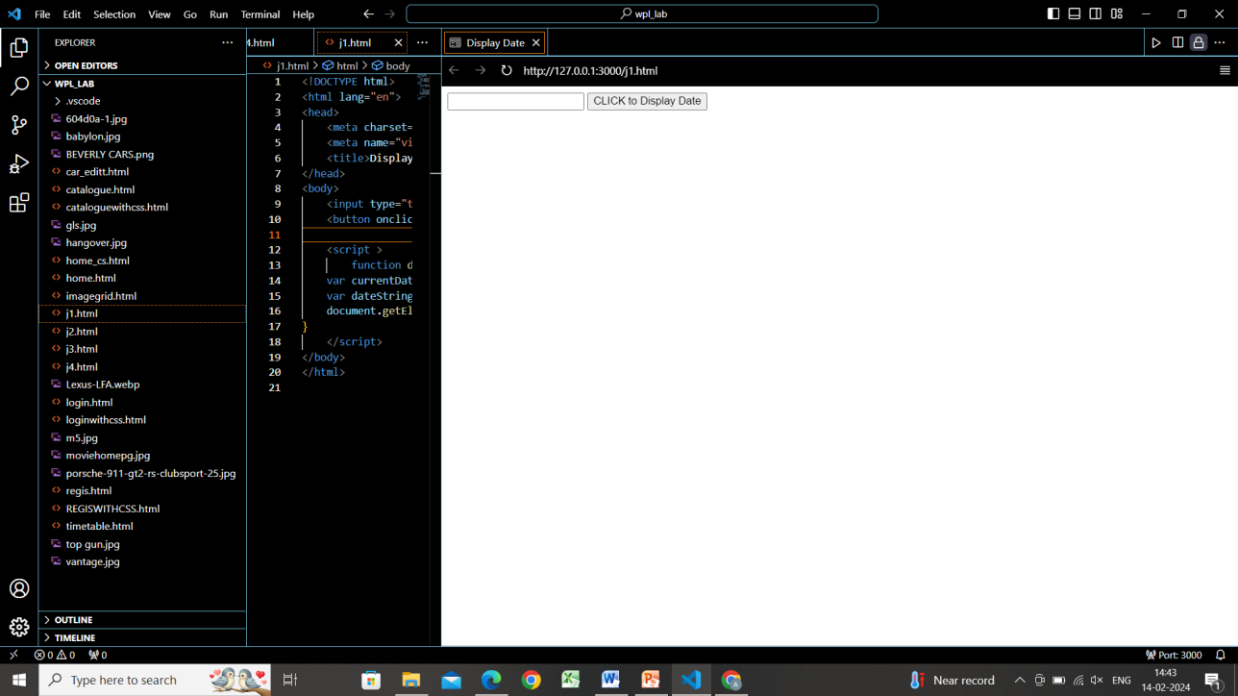
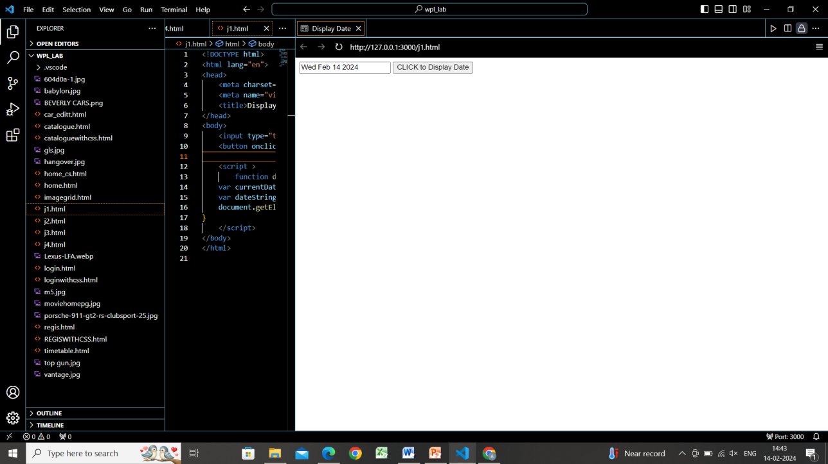
b>
<!DOCTYPE html>
<html lang="en">
<head>
<meta charset="UTF-8">
<meta name="viewport" content="width=device-width, initial-scale=1.0">
<title>Factorial Calculator</title>
</head>
<body>
<script>
// Prompt the user for a number
var userInput = prompt("Enter a number to calculate its factorial:");

// Convert the user input to a number
var n = parseInt(userInput);

// Calculate the factorial
var factorial = 1;
for (var i = 1; i <= n; i++) {
factorial *= i;
}

// Display the factorial using an alert
alert("The factorial of " + n + " is: " + factorial);
</script>
</body>

</html>
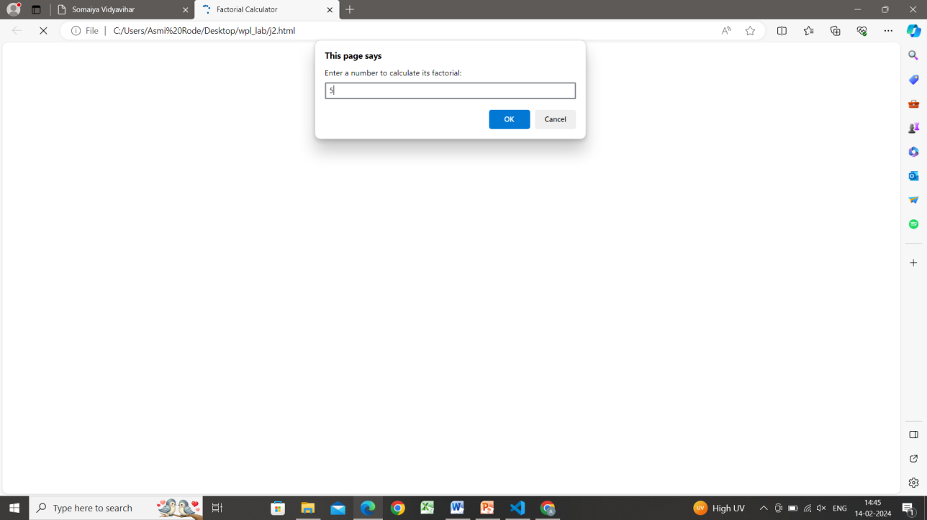
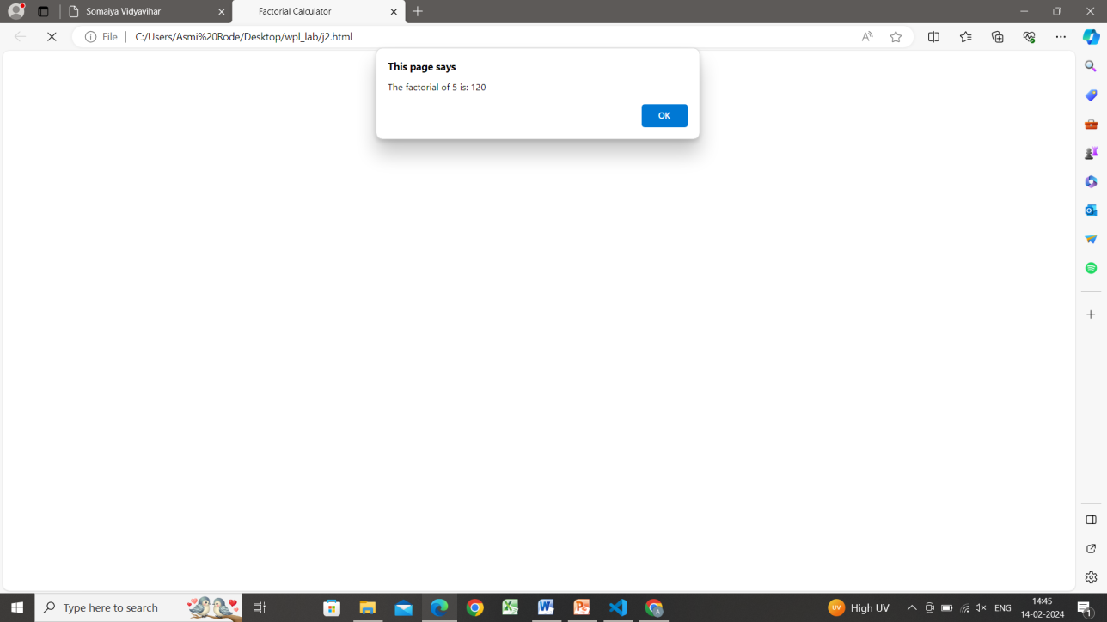
c>
<!DOCTYPE html>
<html lang="en">
<head>
<meta charset="UTF-8">
<meta name="viewport" content="width=device-width, initial-scale=1.0">
<title>Multiplication Table</title>
</head>
<body>
<script>
// Prompt the user for a number
var userInput = prompt("Enter a number:");

// Convert the user input to a number
var n = parseInt(userInput);

// Generate and display the multiplication table
var table = "<h2> Multiplication Table of " + n + "</h2>";
table += "<table border='1'>";
for (var i = 1; i <= 10; i++) {
table += "<tr><td>" + n + " × " + i + "</td><td>=</td><td>" + (n * i) + "</td></tr>";
}
table += "</table>";
document.write(table);
</script>
</body>
</html>

Output:
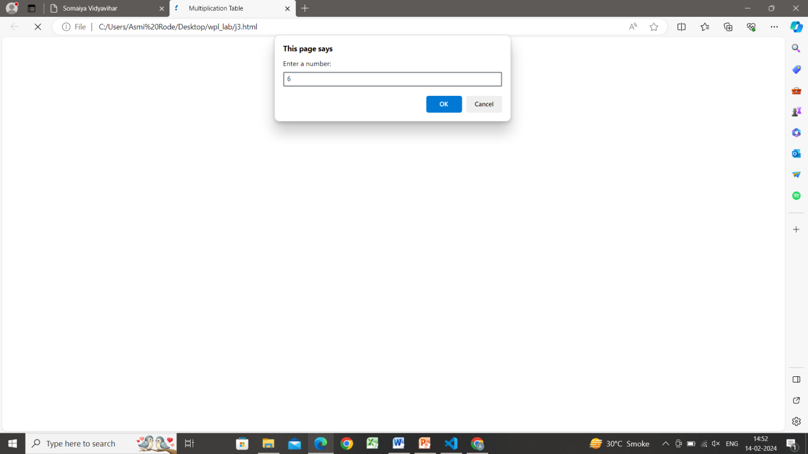
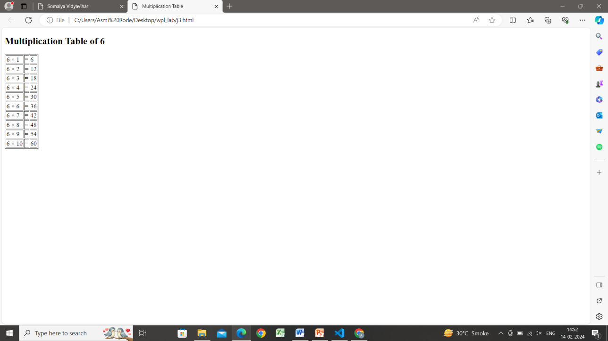
d>
<!DOCTYPE html>
<html lang="en">
<head>
<meta charset="UTF-8">
<meta name="viewport" content="width=device-width, initial-scale=1.0">
<title>Registration Form</title>
<script>
function validateForm() {
var name = document.getElementById("name").value;
var password = document.getElementById("password").value;
var email = document.getElementById("email").value;
var phoneNumber = document.getElementById("phoneNumber").value;

var nameRegex = /^[a-zA-Z]{6,}$/;
var passwordRegex = /^.{6,}$/;
var emailRegex = /^[^\s@]+@[^\s@]+\.[^\s@]+$/;
var phoneNumberRegex = /^\d{10}$/;

if (!nameRegex.test(name)) {
alert("Name should contain alphabets and the length should not be less than 6 characters.");
return false;
}
if (!passwordRegex.test(password)) {
alert("Password should not be less than 6 characters in length.");
return false;
}
if (!emailRegex.test(email)) {
alert("Invalid email format. Please enter a valid email address.");
return false;
}
if (!phoneNumberRegex.test(phoneNumber)) {
alert("Phone number should contain 10 digits only.");
return false;
}

return true;
}
</script>
</head>
<body>
<h2>Registration Form</h2>
<form onsubmit="return validateForm()">
Name: <input type="text" id="name" name="name"><br><br>
Password: <input type="password" id="password" name="password"><br><br>
E-mail: <input type="email" id="email" name="email"><br><br>
Phone Number: <input type="tel" id="phoneNumber" name="phoneNumber"><br><br>
<input type="submit" value="Submit">
</form>
</body>
</html>
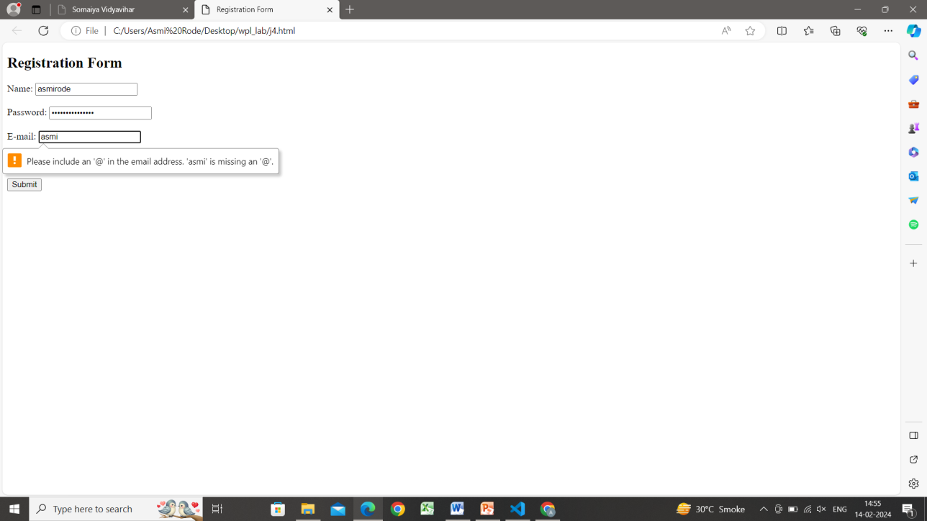

Post Lab Objective with Ans :
- What are the possible ways to create objects in JavaScript?
ANS: With JavaScript, we can define and create your own objects.
There are different ways to create new objects:
- Create a single object, using an object literal.
- Create a single object, with the keyword new.
- Define an object constructor, and then create objects of the constructed type.
- Create an object using Object.create().

- What is the Difference between == and === operators?
ANS:
== in JavaScript is used for comparing two variables, but it ignores the datatype of variable.
=== is used for comparing two variables, but this operator also checks datatype and compares two values.
- What is the difference between let and var?
ANS:
The keywords let and var both declare new variables in JavaScript. The difference between let and var is in the scope of the variables they create:
Variables declared by let are only available inside the block where they’re defined.
Variables declared by var are available throughout the function in which they’re declared.

